Teen Summer
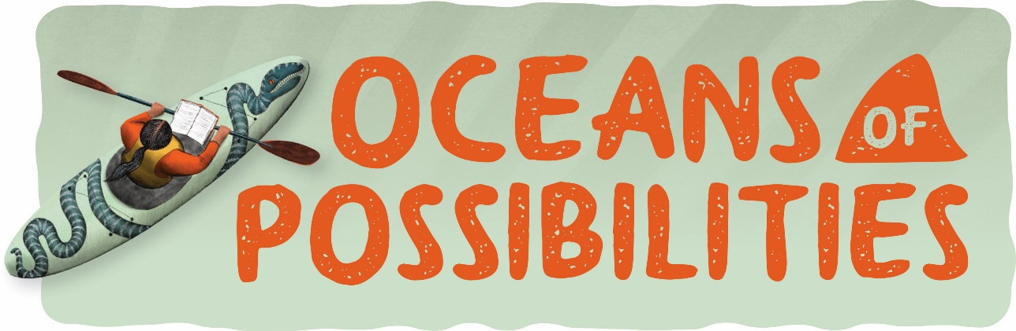
Reading Challenge 2022

The Teen Summer Reading Challenge is open to the ages of 13-17 that have an active library card for the Presque Isle District Library. Registration will open June 1st and forms will
be available at each of our branches.

We will have incentives to reward the teens with the most pages read of the summer! Register at any PIDL Library and fill out a reading slip with your name, title, author and ISBN after every book you read and turn it into your home branch. (Graphic novels count too!) Page numbers will be added up at the end of the program on July 31st and winners will be announced by August 10th.
Check out our Facebook page for Summer Reading Program events.

